|  |  |
| --- | --- |
| Trigger Box | |
| Specification | |
| Author: | Bengt Ragnemalm |
|  |  |
|  |  |
|  |  |

Document history

|  |  |  |  |
| --- | --- | --- | --- |
| Version | Date | Comment | Author |
| 1.0 | 2018-12-18 | Initial release | Bengt Ragnemalm Medicinsk Teknik Region Östergötland |
| 1.1 | 2019-02-27 | New data formats | Bengt Ragnemalm |
| 1.2 | 2019-04-05 | More detailed descriptions | Bengt Ragnemalm |
| Development is from here made internal at LiU | | | |
| 1.3 | 2021-12-02 | - Added 2 Analogue In channels. - Added serial output of the analogue channels to WinSC. - Changed baud rate | Bengt Ragnemalm |

Table of Contents

1 Specification 4

1.1 Picture from design meeting between Sarah and Bengt 2018-12-18 4

2 Physical 4

3 Software 4

3.1 Data format 4

3.2 Commands 5

3.2.1 Command time-out 5

3.2.2 Digital Trigger 5

3.2.3 Analogue Trigger 5

3.2.4 Cancel Trigger 5

4 Hardware 6

4.1 Power 6

4.2 Parts 6

4.3 Connections 6

4.4 Schematics 7

4.4.1 Arduino MKR Zero 7

4.4.2 PmodUSBUART 8

4.4.3 PmodRS232 8

4.4.4 PmodDA4 8

5 Programming 9

5.1 Connection of debugger 9

# Specification

## Picture from design meeting between Sarah and Bengt 2018-12-18

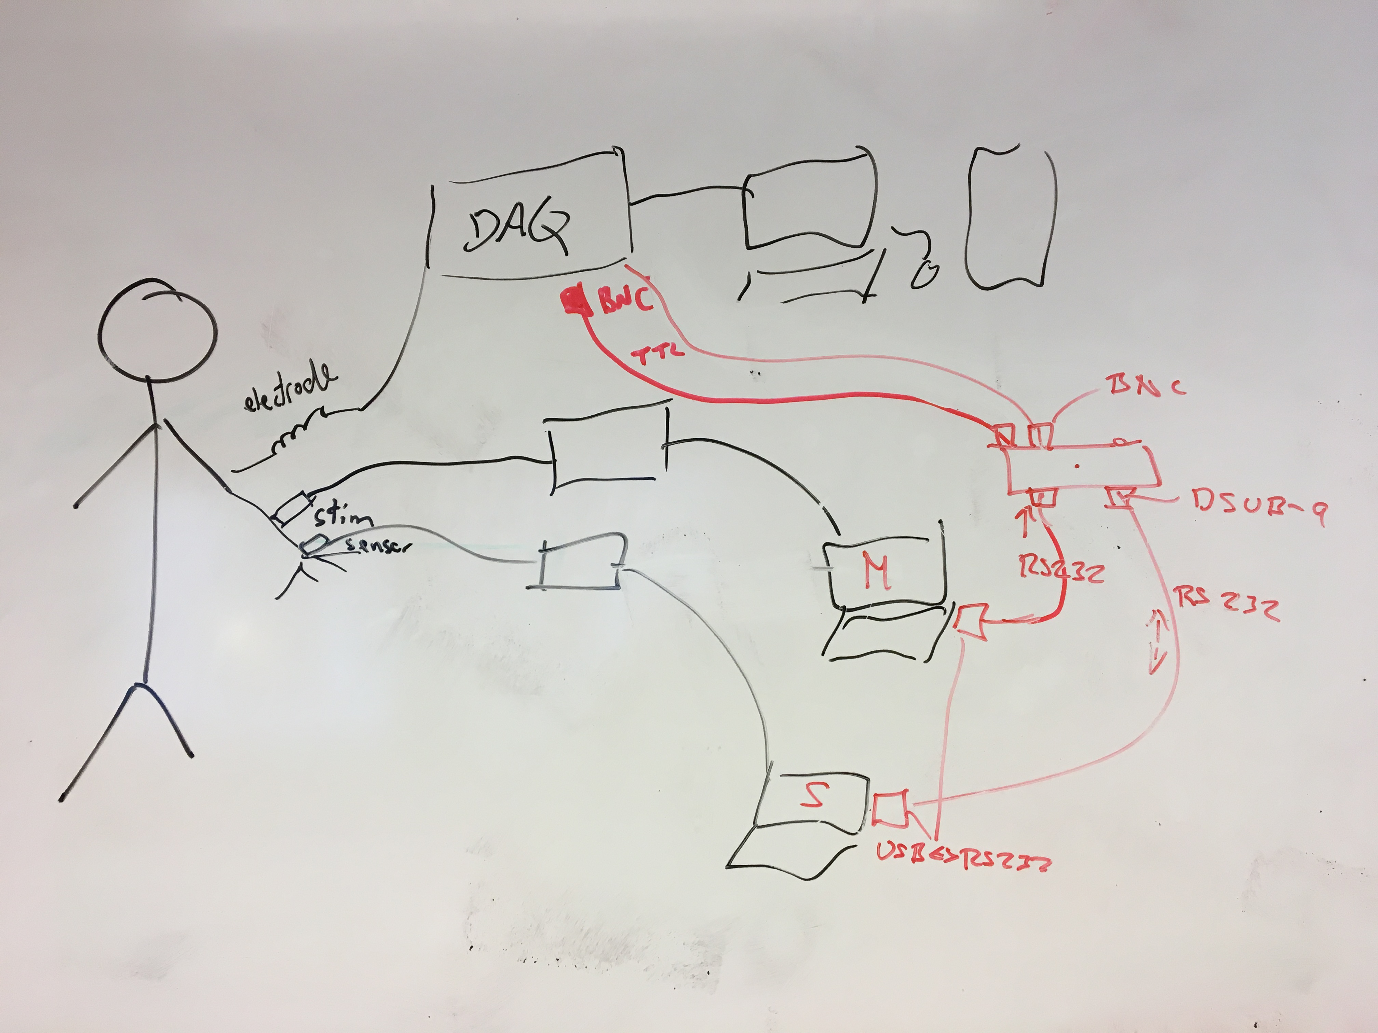

# Physical

Connections:

Digital

Nr 1. USB input/output. Converted to RS232 inside the box.

Also used for power. 5 V, < 100 mA.

The controlling PC must be connected to this port.

Nr 2. RS232 output. DSUB-9, female.

Analogue outputs:

Nr 3-7. BNC, 5 psc. Current limited with 1 k ohm resistors.

Reset push button

# Software

## Data format

For simplicity, most command uses the same length and data format as below. Each rectangle represents one 8 bit byte.

|  |  |  |  |  |  |  |
| --- | --- | --- | --- | --- | --- | --- |
| Byte nr: | 0 | 1 | 2 | 3 | 4 | 5 |
| Purpose: | Start | Commandn nr | Param 1 | Param 2 | Param 3 | Param 4 |

Start character = ‘S’. In case of failure in the data transmission there is a command time-out of 500 ms after the command handler is reset.

Baud rate is 1200. There is no hardware handshaking.

## Commands

Command input must be done on connector 1.

Output can be on any of the analog or digital outputs. Sending a level on a digital output will have no effect.

Note: Unused parameters must always be filled up with zeroes as the command handler always expects 4 parameters.

Parameters for command 01-03 are all 8 bits integers.

### Command time-out

In case of failure there is a time-out of 2 seconds for commands.

### Digital Trigger

This command will send out one byte to one of the digital outputs. The time from receiving the command to sending out the trigger is set by the parameters. If Time is 0 the byte will be sent imediatelty.

Format:

|  |  |  |  |  |  |
| --- | --- | --- | --- | --- | --- |
| Byte 0 | Byte 1 | Byte 2 | Byte 3 | Byte 4 | Byte 5 |
| Start character | Param 1 | Param 2 | Param 3 | Param 4 | Param 5 |
|  | Command nr | Output | Byte to send | X = Time MSB.  Time = X * 10 ms).  X is 16 bits splitted on parameter 4 and 5. | X = Time LSB |
| ‘S’ | 1 | 3-7 | 0-255 1) | Param 4 & 5 = 0-65535 | |

1) To send a character for example ‘A’ just transfer the character ‘A’ since that is the same as sending the ASCII code of ‘A’ which is 65 (dec) or 41 (hex).

### Analogue Trigger

This command will send out an analogue trigger signal to one of the analogue outputs. The trigger will be active from receiving the command until the time set by the parameters. I.e. Time sets the pulse width.

Format:

|  |  |  |  |  |  |
| --- | --- | --- | --- | --- | --- |
| Byte 0 | Byte 1 | Byte 2 | Byte 3 | Byte 4 | Byte 5 |
| Start character | Param 1 | Param 2 | Param 3 | Param 4 | Param 5 |
|  | Command nr | Output | Output level. Output voltage = value/10 | X = Time MSB.  Time = X * 10 ms).  X is 16 bits splitted on parameter 4 and 5. | X = Time LSB |
| ‘S’ | 2 | 1-7 | 0-50 | Param 4 & 5 = 0-65535 1) |  |

1) If time is set to 0 the output will be on forever.

### Cancel Trigger

This command will cancel a previously activated trigger.

Format:

|  |  |  |  |  |  |
| --- | --- | --- | --- | --- | --- |
| Byte 0 | Byte 1 | Byte 2 | Byte 3 | Byte 4 | Byte 5 |
| Start character | Param 1 | Param 2 | Param 3 | Param 4 | Param 5 |
|  | Command nr | Output | Not used | Not used | Not used |
| ‘S’ | 3 | 1-7 | 0 | 0 | 0 |

### Analog inputs to WinSC

This is a very special command dedicated to transfer analogue data to WinSC which is a software for Umeå 8 channel Vf system. The command will make the box read data from the analogue input and transfer the data in WinSc format through RS232, digital port nr 2. The hardware makes it possible to add up to a maximum of two analogue inputs if needed.

Command format:

|  |  |  |  |  |  |
| --- | --- | --- | --- | --- | --- |
| Byte 0 | Byte 1 | Byte 2 | Byte 3 | Byte 4 | Byte 5 |
| Start character | Param 1 | Param 2 | Param 3 | Param 4 | Param 5 |
|  | Command nr | Input | Not used | Not used | Not used |
| ‘S’ | 4 | 0 | 0 | 0 | 0 |

Output format:

# Hardware

## Power

All circuit boards except PmodDA4 use +3.3V to power the internal circuitry. The +3.3V power is delivered from the external USB supply through the PmodUSBUART.

+5V is used to power the PmodDA4 to get 5V output capability. This power is picked up directly at the PmodUSBUART board at C6, inner side closest to USB connector.

PmodDA4 is supplied with VCC = +5 V and is patched to modify the DAC reference to VCC. PmodDA4 has only inputs and is therefore fully compatible with +3.3V without any level shifters.

## Parts

CPU board: Arduino MKR Zero  
Microcontroller chip: ATSAMD21G18A

USB to serial UART interface PmodUSBUART  
USB to to UART converter chip: FT232RQ  
Jumper set to pos VCC-SYS3V3  
Jumper between J2-1 and J2-4

RS232 interface PmodRS232  
RS232 to UART converter chip: ADM3232E  
Jumpers set to:  
JP1 Open  
JP2 closed

Analogue output interface PmodDA4. Eight channel analogue outputs  
DAC chip: AD5628, 12 bit resolution.  
The board is patched to output 0-5 V by means of a connection between C1+ and IC1 pin 7

## Connections

|  |  |  |  |  |
| --- | --- | --- | --- | --- |
| Arduino MKR Zero | PmodUSBUART | PmodRS232 | PmodDA4 | BNC out |
| VCC | J2-6 | J1-6 |  |  |
| GND | J2-5 | J1-5 | J2-5 | Common GND |
|  | C6+ (USB +5V) |  | J2-6 |  |
| TX (out) [USART 5] | J2-2 (RX, in) |  |  |  |
| RX (in) [USART 5] | J2-3 (TX, out) |  |  |  |
| A5 (out) [USART 0] |  | J1-4 (RX, in) |  |  |
| A6 (in) [USART 0] |  | J1-3 (TX, out) |  |  |
| SCK |  |  | J2-4 (SCLK) |  |
| MOSI |  |  | J2-2 (DIN) |  |
| 7 (I/O PA21) |  |  | J2-1 (SYNC) |  |
|  |  |  | Out 0 | 3 |
|  |  |  | Out 1 | 4 |
|  |  |  | Out 2 | 5 |
|  |  |  | Out 3 | 6 |
|  |  |  | Out 4 | 7 |

## Schematics

### Arduino MKR Zero

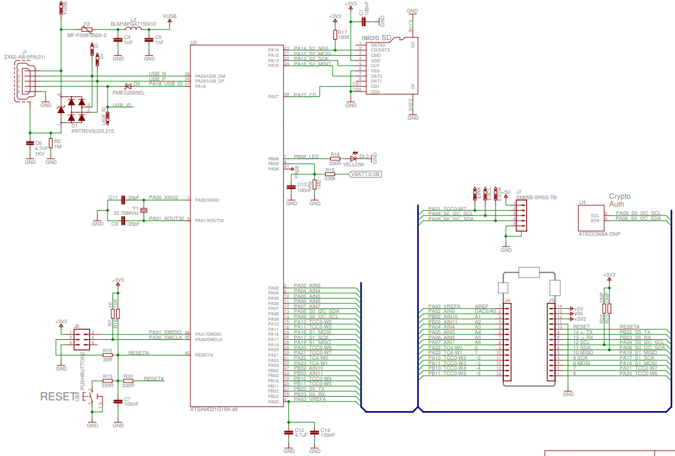

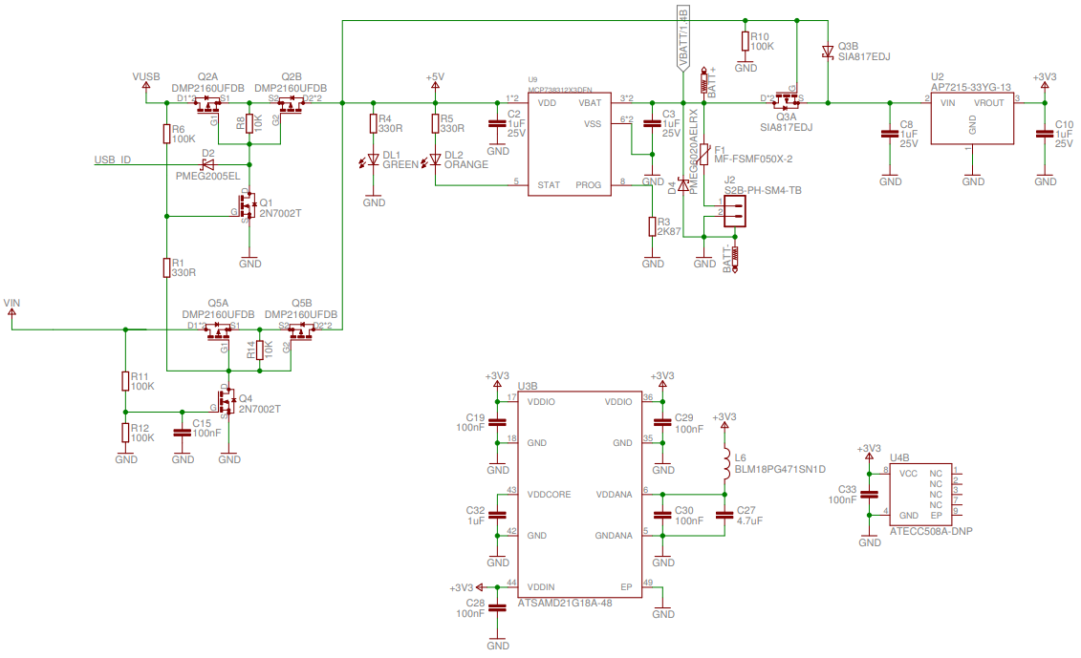

### PmodUSBUART

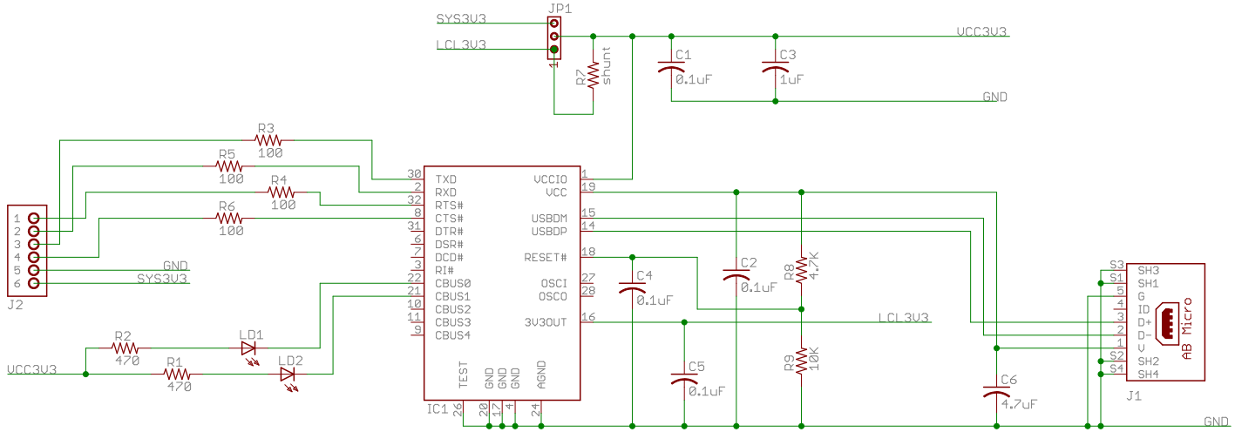

### PmodRS232

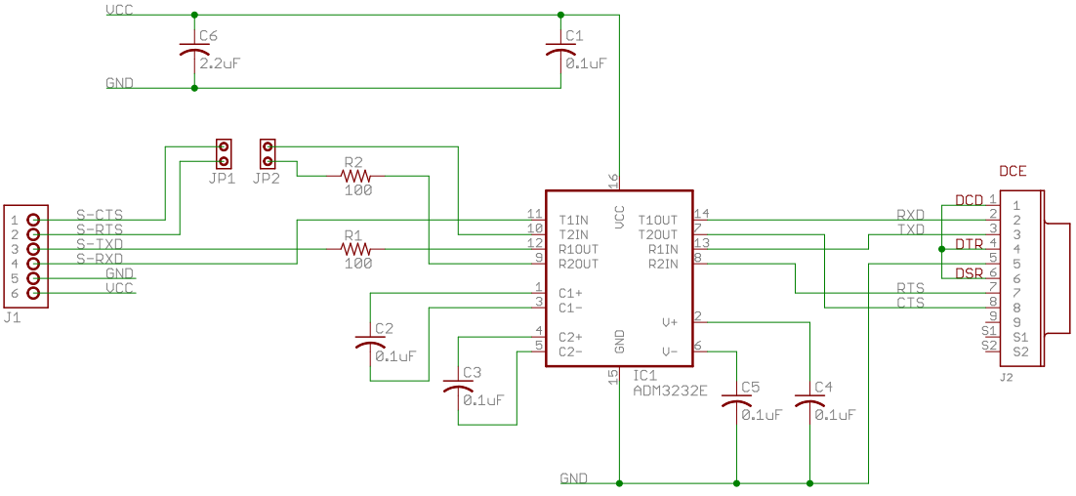

### PmodDA4

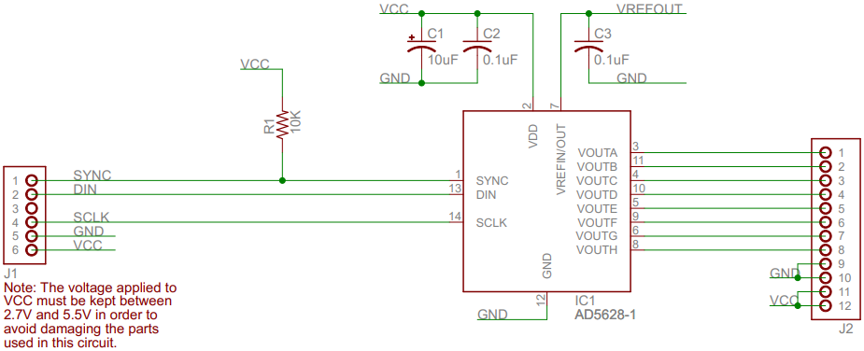

# Programming

Arduino MKR Zero is not using the Arduino bootloader or programming interface. All Arduino related code on the board has been erased. (The bootloader is still intact but not intended to be used). Instead it is programmed and debugged directly over the JTAG interface of the back of the board. An Atmel-ICE has been used for debugging/programming but there are other compatible debuggers.

## Connection of debugger

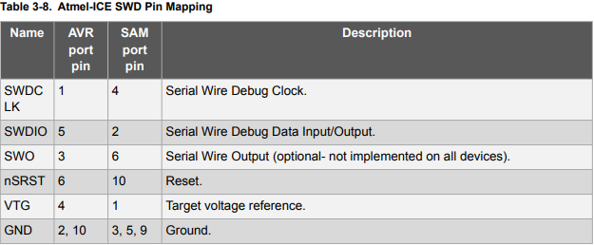

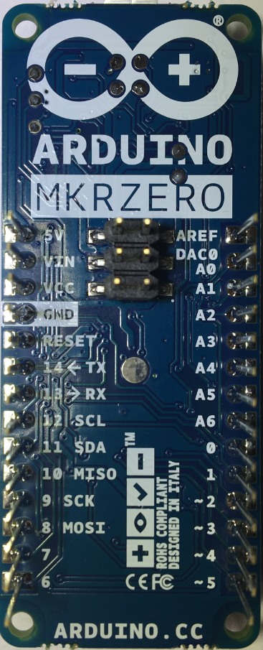

|  |  |
| --- | --- |
| ICE | SAM |
| NC | NC (-6) |
| #4 | SWCLK-4 |
| #2 | SWDIO-2 |

(There are no SWO

pin on SAMD21)

|  |  |
| --- | --- |
| SAM | ICE |
| 5- GND | #3,5,9 |
| 3- nSRT | #10 |
| 1- Vref | #1 |